CITY OF MANTON
WEXFORD COUNTY, MICHIGAN
NOTICE OF OFFER FOR SALE AND INVITATION FOR SUBMISSION OF COMPETIVE BIDS
FOR CITY OWNED VACANT REAL PROPERTY

PLEASE TAKE NOTICE that the City of Manton, whose offices are located at 306 W. Main St., Manton, Michigan, 49663, is offering for sale City-owned vacant real property located at 306 West Street. The property is roughly 60’ x 150’and is located east of West Street and south of Griswold Street. Street level and aerial photos of the property are inset below:

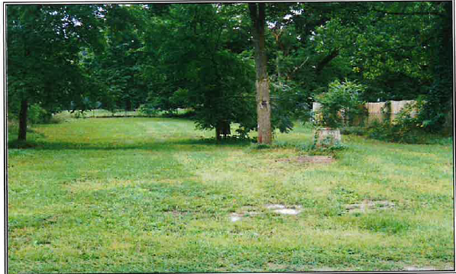

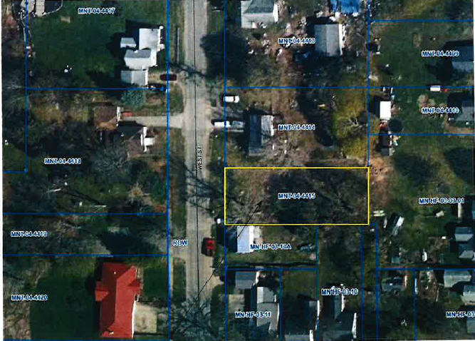

Members of the public are invited to submit bids in sealed envelopes identifying the purchase price offered for the property and the name, address and phone number of the person making the bid, by delivering the bid to the City offices located at 306 W. Main St., Manton, Michigan, 49663, by 3 p.m. Friday, November 13, 2026. Any bid over the amount of $9,000 will be considered.
The bids shall be opened and read aloud by the City Clerk at the City Commission meeting 7 p.m. on Tuesday, November 17, 2026, at the Manton Senior Center, located at 302 W. Main St. Manton, Michigan, 49663. Thereafter, the City Clerk shall report the bids to the City Commission at this same meeting on November 17, 2026. The City Commission may accept or reject any and all bids if deemed advisable.

